**ITP Mini Project**

**Courier Management System**

For a seamless eCommerce shopping experience, it is essential to deliver the product promptly to the customer. And that’s where a professional courier service plays a vital role. 'FastTrack' courier company stores the relevant data of its clients and parcels in the form of dictionary. Create a dictionary for storing shipment information in key-value pairs. Shipment id is used as a key and list of other attributes like sender, receiver, start date, Delivery Date, Sender_location, Receiver_location, Delivery status, Shipping cost is associated with shipment id. Use the data shown in the table below.

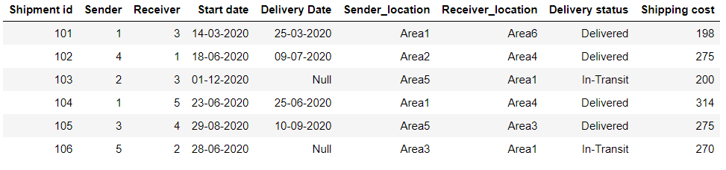

Use below table to refer to client’s data. Please note that a client can be a sender or receiver.

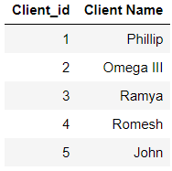

**Q1. Create a Dictionary of lists to store the information of shipments given in the table. The key should be the shipment id and the value with it’s details.**

**Q2. Create a Dictionary to store the information of clients given in the table.**

### Q3. Write a code to replace client’s id with their respective name in shipment dictionary using a loop and dictionary comprehension

### Q4. Print all shipment details that are sent by Phillip

### Q5. Print all shipment details that are received by Ramya

### Q6. Print all shipments which are in 'In-Transit' status

### Q7. Print all shipments which are delivered within 7 days of courier Start date

### Q8. Print all shipments which are delivered after 15 days of courier start date or not yet been delivered.

### Q9. Print the shipment details whose shipment cost in the range of 200 to 300

### Q10. Print the name of all senders whose delivery status is ‘in-transit’.

### Q11. Print the shipment ID that has the highest shipment cost.

### Q12. Print all the shipment details that are delivered by ‘John’ and received by ‘Omega III’